Yorkshire Philosophical Society

Blue Plaque Walk around York
Wednesday 4 October 2023 from 2pm to 4.30pm
Cost: £8 per person

Have you ever wondered how many members of the YPS have been honoured by a blue plaque? Why not join members of the Society as we take a walk through York identifying some of those blue plaques and learn a little more about the people they celebrate? The tour will start at the footbridge by St Peter’s School (the river side) at 2 pm and will end in the middle of York after a short break for refreshment.

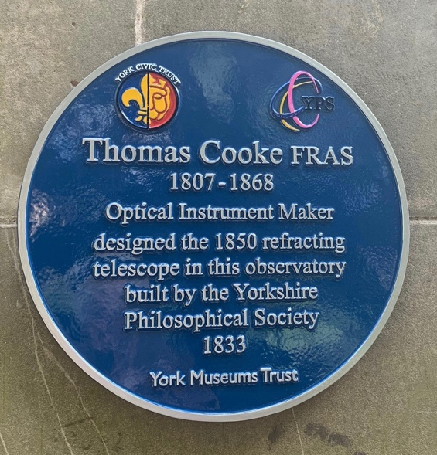

Please detach and complete the form below and return it to the YPS Lodge with a cheque for £8.00 per person made out to Yorkshire Philosophical Society. Please enclose SAE if no email address available. Alternatively, pay by Paypal and email your details to us.

Note that YPS Activities booking terms and conditions will apply and can be seen at the Lodge or online: http://www.ypsyork.org/groups/social-group/yps-activities-booking-terms-conditions-2/

Your personal details will only be stored and used to administer this event.
........................................................................................................................................
Blue Plaque Walk Wednesday 4 October 2023
Please return this by 15 September 2023
to: Dorothy Nott, c/o Yorkshire Philosophical Society, The Lodge, Museum Gardens, York, YO1 7DR.

Please reserve …….. places for me/us. A cheque for £ …..… (£8 per person) made out to Yorkshire Philosophical Society is enclosed. (NB The Society’s full name is needed on cheques now please.)

Alternatively, pay online using the Paypal link on our website - https://www.ypsyork.org/donate-to-yps/ - and email your details to info@ypsyork.org (No Paypal account is needed, just a credit or debit card.)

Name(s) ………………………………………………………………………………………………………………………………………………
Address ………………………………………………………………………………………………………………………………………………
Tel. No. …………………………………..……………………… Mobile…………………………………..…………………………………
(A mobile number is very useful if we need to contact you on the day)
Email*…………………………………………………………………………..…………………
*Acknowledgement will be by email. Please send sae if postal acknowledgement is required.

