Yorkshire Philosophical Society

**YPS Garden Party Celebration Event**

Friday 20th June 2025 from 2.30pm to 4.30pm

£23 per person

Members are invited to join us at the York Medical Society Rooms at 2.30pm for a celebration to include a short presentation, followed by time to talk to friends both new and longstanding, over included Afternoon Tea of sandwiches, canapés, cakes and drinks. There will also be a chance to explore the secret garden here, weather permitting, and to look at the Tempest Anderson Exhibition, and it may be possible to take a tour of the building.

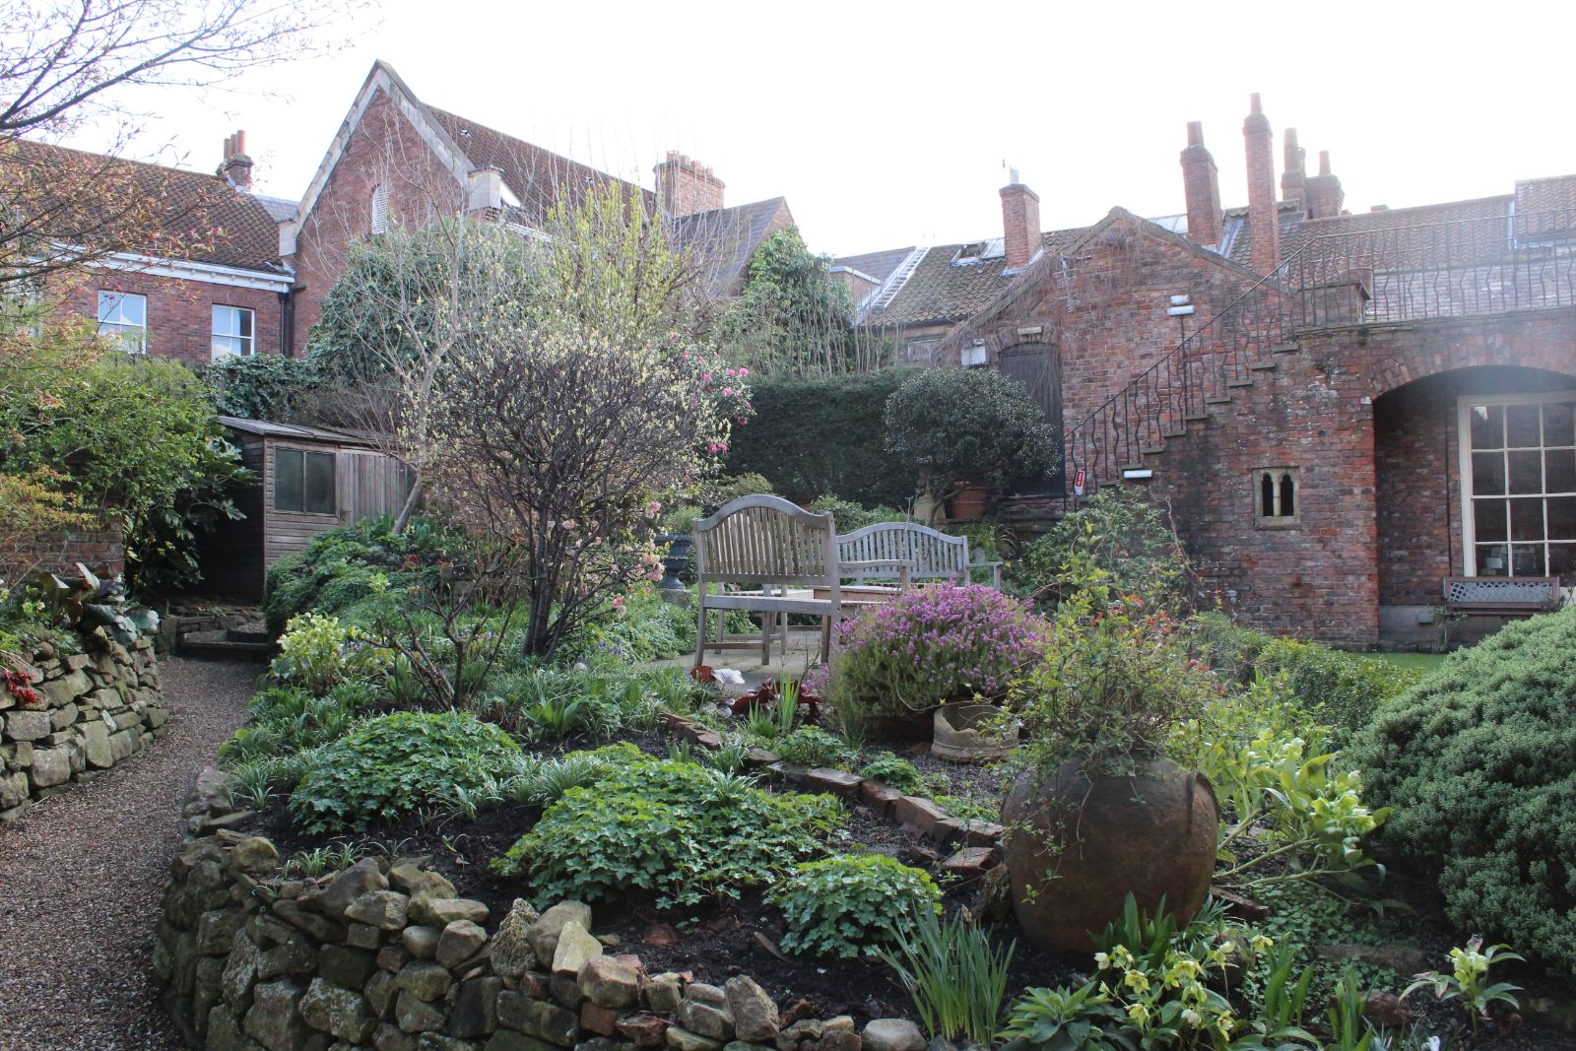

Note that YPS Activities booking terms and conditions will apply and can be seen at the Lodge or online.

<http://www.ypsyork.org/groups/social-group/yps-activities-booking-terms-conditions-2/>

*Please detach and complete the form below and return it to the YPS Lodge with a cheque made out to Yorkshire Philosophical Society or pay online and return the form by email. Please enclose SAE if no email address available.*

**...................................................................................................................................................................YPS Garden Party - 20 June 2025 *(Please return this by 10 June)***

To: Catherine Brophy, Yorkshire Philosophical Society, The Lodge, Museum Gardens, York, YO1 7DR.

Please reserve …….. places for me/us. (£23 per person).

Pay online by PayPal (no account needed you can use debit/credit cards) at YPS payments: <https://www.ypsyork.org/donate-to-yps/> and email your details to: [info@ypsyork.org](mailto:info@ypsyork.org) or send this form with your cheque.

A cheque for £ …..… made out to Yorkshire Philosophical Society is enclosed (N.B. The Society’s full name is needed on cheques now please).

Please indicate below:

Name(s) ………………………………………………………………………………………………………………………………………………………

Tel. No. ……………………………….………………………………Mobile…………………………………..……………………………………….

(A mobile number is very useful if we need to contact you on the day or in case of any changes.)

Email ………………………………………………………………………………………………………………………………………………………………..

*Please enclose SAE if no email address available*

Special dietary requirements ……………………………………………………………………………………………………………………………………