Yorkshire Philosophical Society

**Visit to Quarry Bank (NT)**

Thursday 4th September 2025 from 8.45am to 6pm

£30 per person to include coach and driver gratuity

National Trust Members free entry/Non-Members £22.80 entry fee for the whole site payable on the day

Our visit to Quarry Bank Mill, south of Manchester, is well worth a full day’s visit, comprising as it does, the Mill, the Apprentice House, Styal Village, Gardens and Estate. Dating back to 1784 and now a Grade II* listed building, Quarry Bank has been called ‘the most complete and least altered factory colony of the Industrial Revolution’ and ‘of outstanding national and international importance’ by the Council of Europe. Originally started by Samuel Greg with technology provided by Matthew Boulton and James Watt (the Lunar Men), thanks to Hannah Greg, the lives of the workers, although still hard, were somewhat alleviated by estate housing, medical attention and education for the apprentices. The mill continued in production until 1959. A well as the industrial buildings, there are acres of woodland to explore along the river Bollin.

*Members of York Association of the National Trust (YANT) are most welcome to join us.*

The Ingleby’s coach will leave from York Memorial Gardens at 8.45am and we will return to York by 6pm approximately. Lunch is not included, there is both a Café and the Weaving Shed Restaurant or bring a picnic.

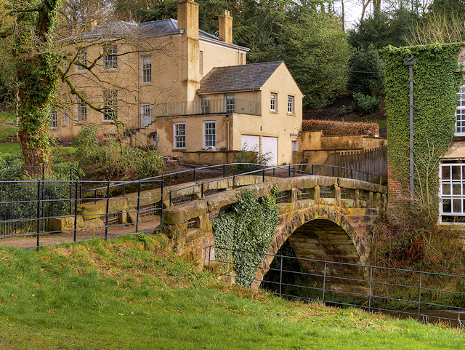

Note that YPS Activities booking terms and conditions will apply and can be seen at the Lodge or online.

<http://www.ypsyork.org/groups/social-group/yps-activities-booking-terms-conditions-2/>

*Please detach and complete the form below and return it to the YPS Lodge with a cheque made out to Yorkshire Philosophical Society. Please enclose SAE if no email address available. Or book by email and Paypal – see below. Your personal details will only be stored and used to administer this event.*

**................................................................................................................................................................... Visit to Quarry Bank - 4th September 2025 (*Please return this by 4th August 2025)***

To: Dorothy Nott, c/o YPS, The Lodge, Museum Gardens, York, YO1 7DR Pay online by PayPal (no account needed you can use debit/credit cards) at YPS payments: <https://www.ypsyork.org/donate-to-yps/> and email your details to: [info@ypsyork.org](mailto:info@ypsyork.org) or send this form with your cheque.

Please reserve ……... places for me/us. A cheque for £ …..… made out to Yorkshire Philosophical Society is enclosed (£30 per person) (NB The Society’s full name is needed on cheques now please.) Please indicate below:

YPS member Y/N YANT member Y/N National Trust member Y/N

Name(s) ………………………………………………………………………………………………………………………………………………………

Address ………………………………………………………………………………………………………………………………………………………

Tel. No. …………………………………..…………………………………Mobile…………………………………..…………………………………

(A mobile number is very useful if we need to contact you on the day or in case of changes.)

Email*…………………………………………………………………………..…………………

*Acknowledgement will be by email. Please enclose SAE if postal acknowledgement required instead.